
Jenkins Task -3
- Create one jenkins job using the below code and create three stages.
stage1: Git clone to download the source code.
stage2: Sonarqube Integration to check the quality of code.
stage3: Slack Integration to send the alerts to slack.
URL: https://github.com/betawins/VProfile-1.git

Stage 1 : To clone the source code :
- Create jenkins job - freestyle , add repository url in source code management ,
- Also pass credentials if repository is private , if public not neccesary . and also branch specifier
- ( /main or /master ).
- Save .
- Build job manually.
- Build job manually

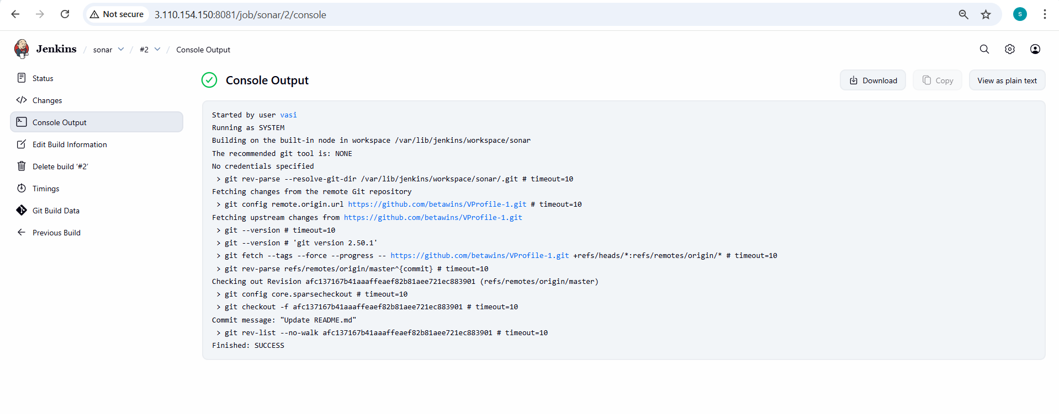
Stage 2 : Sonarqube integration to check the quality of code :
- Steps for sonarqube install and integrate.
- launch ec2 with large instance type , and configure storage of 20 gb , open ports 22 for ssh , 9000 for sonarqube , 5432 for postgresSQL
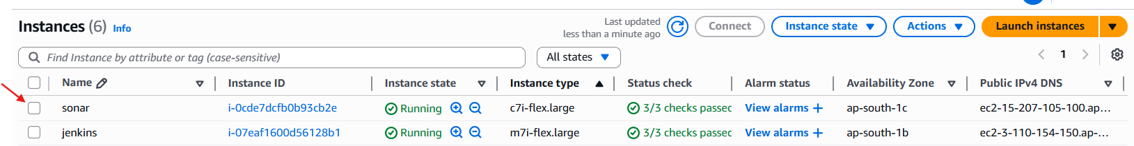
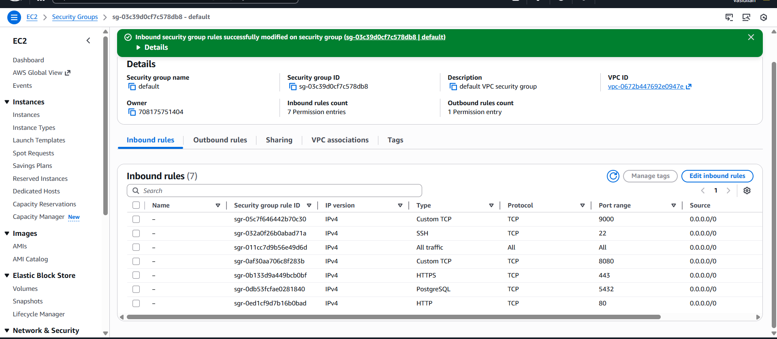

- launch the sonarqube server :
ssh -i "jenkins.pem.pem" ec2-user@ec2-15-207-105-100.ap-south-1.compute.amazonaws.com
- install java latest version
- sudo yum update -y
- sudo dnf install java-17-amazon-corretto -y
- java -version
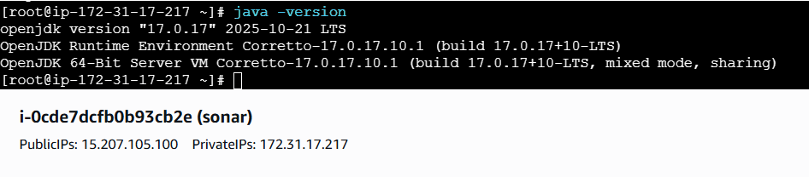
- install postgreSQL
- sudo dnf install postgresql15-server postgresql15-contrib -y
- Initial the database :
- sudo postgresql-setup --init
- sudo sysctl -w vm.max_map_count=262144
- sudo sysctl -w fs.file-max=65536
- echo "vm.max_map_count=262144" | sudo tee -a /etc/sysctl.conf
- echo "fs.file-max=65536" | sudo tee -a /etc/sysctl.conf
- sudo sysctl -p
- sysctl vm.max_map_count
- sysctl fs.file-max
- systemctl start postgresql.service
- systemctl status postgresql.servic

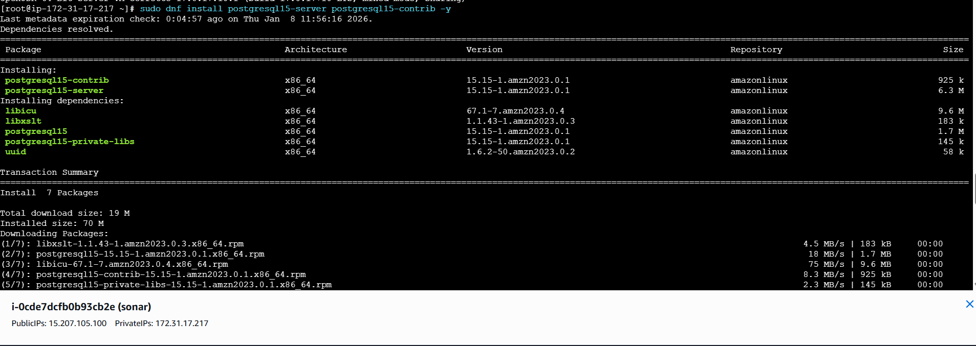

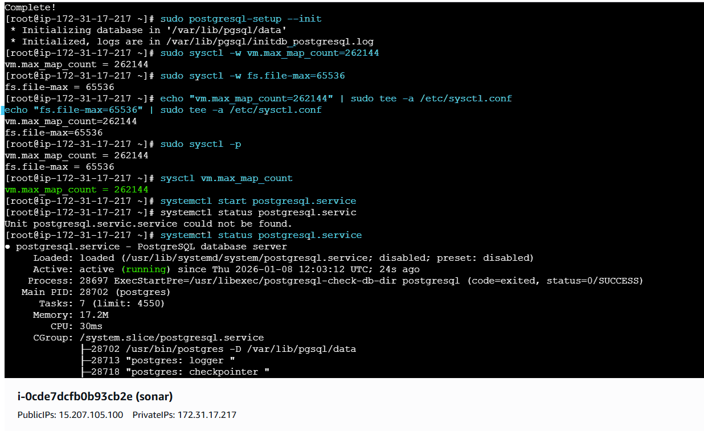
- Login to postgresql and create database :
- su - postgres (or) psql -U postgres -h localhost
psql
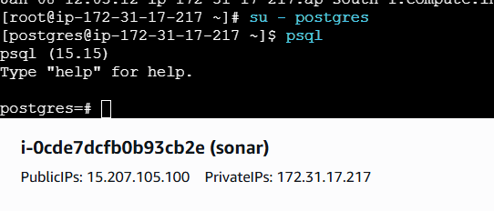
- CREATE DATABASE sonarqube;
- CREATE USER sonar WITH PASSWORD 'sonar@123';
- GRANT ALL PRIVILEGES ON DATABASE sonarqube TO sonar;
- ALTER DATABASE sonarqube OWNER TO sonar
- ALTER USER postgres WITH PASSWORD 'postgres';
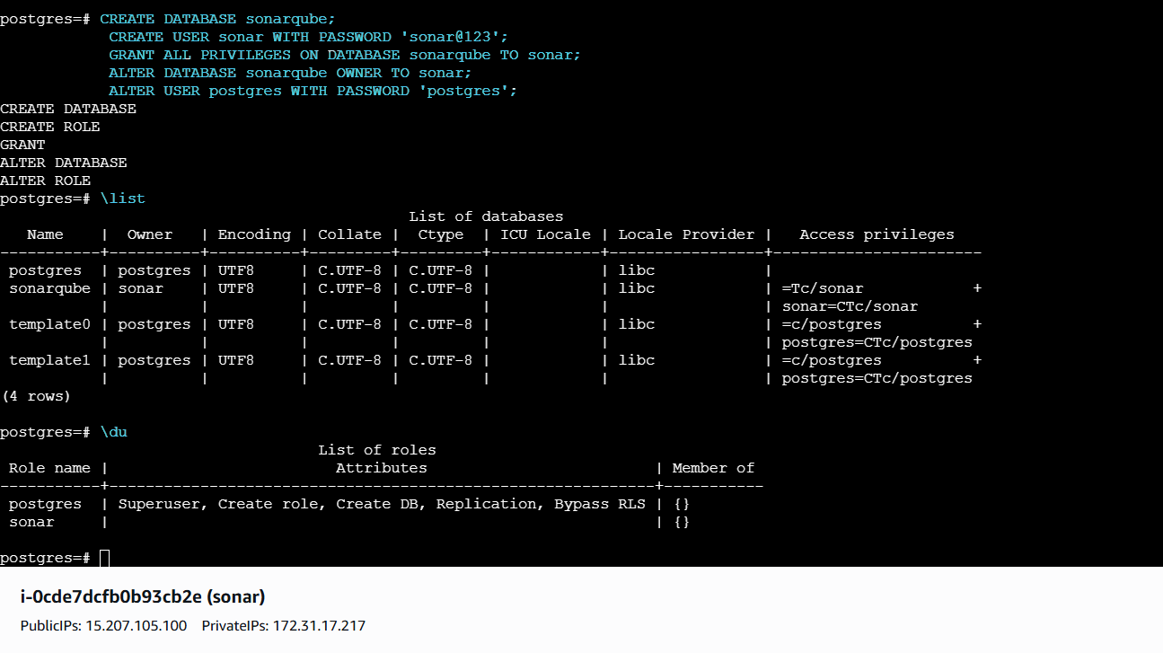
- Exit from postgres.
- sudo find /var/lib/pgsql -name pg_hba.conf === in this change all to md5 from ident

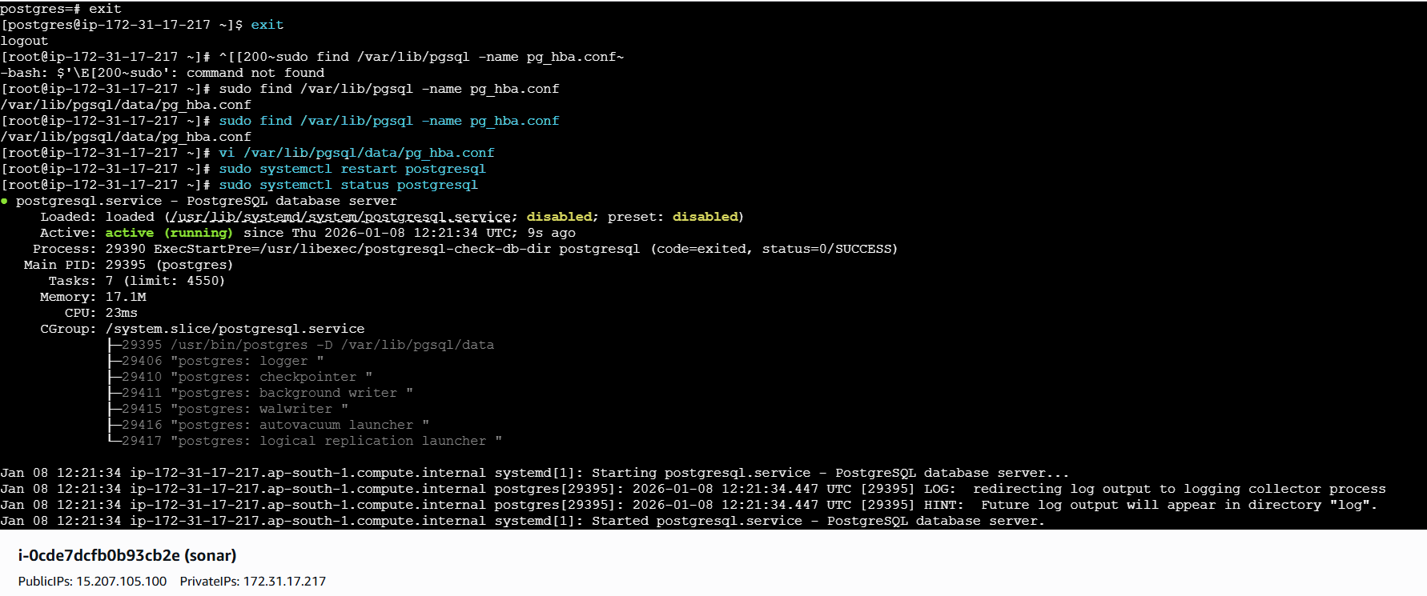
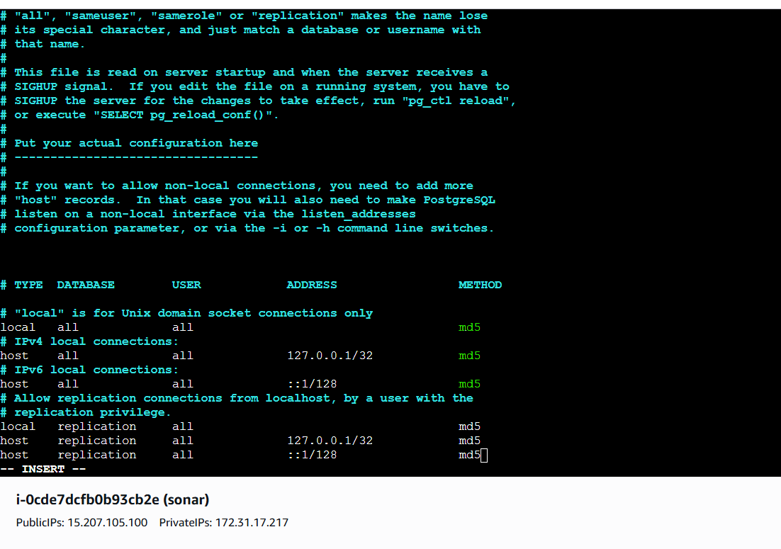
- Install sonarqube in /opt
- cd /opt
- sudo yum install wget unzip -y
- sudo wget https://binaries.sonarsource.com/Distribution/sonarqube/sonarqube-9.9.3.79811.zip
- sudo unzip sonarqube-9.9.3.79811.zip
- sudo mv sonarqube-9.9.3.79811 sonarqube
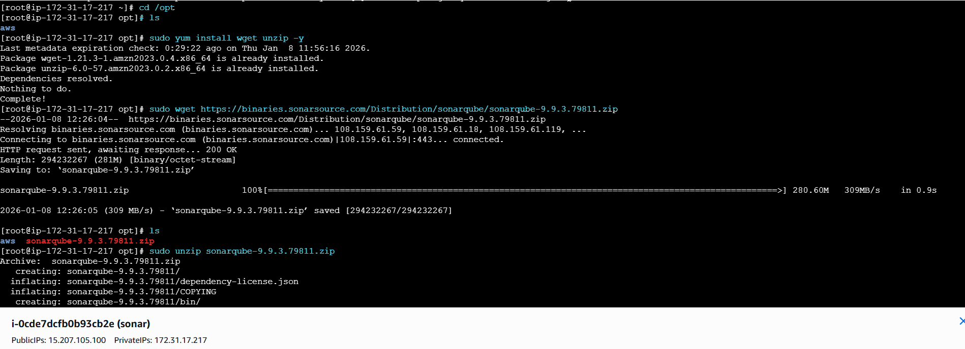
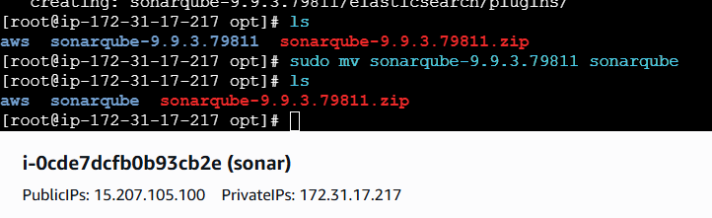
change sonar.properties : at == /sonarqube/conf/sonar.properties
- vi sonar.properties
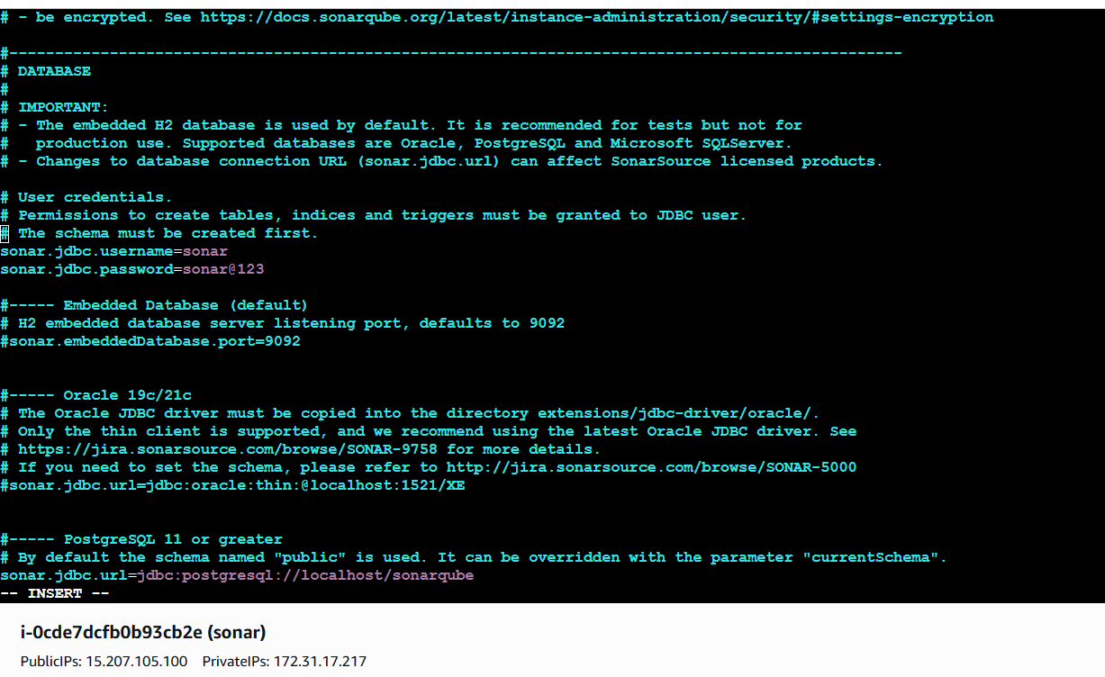
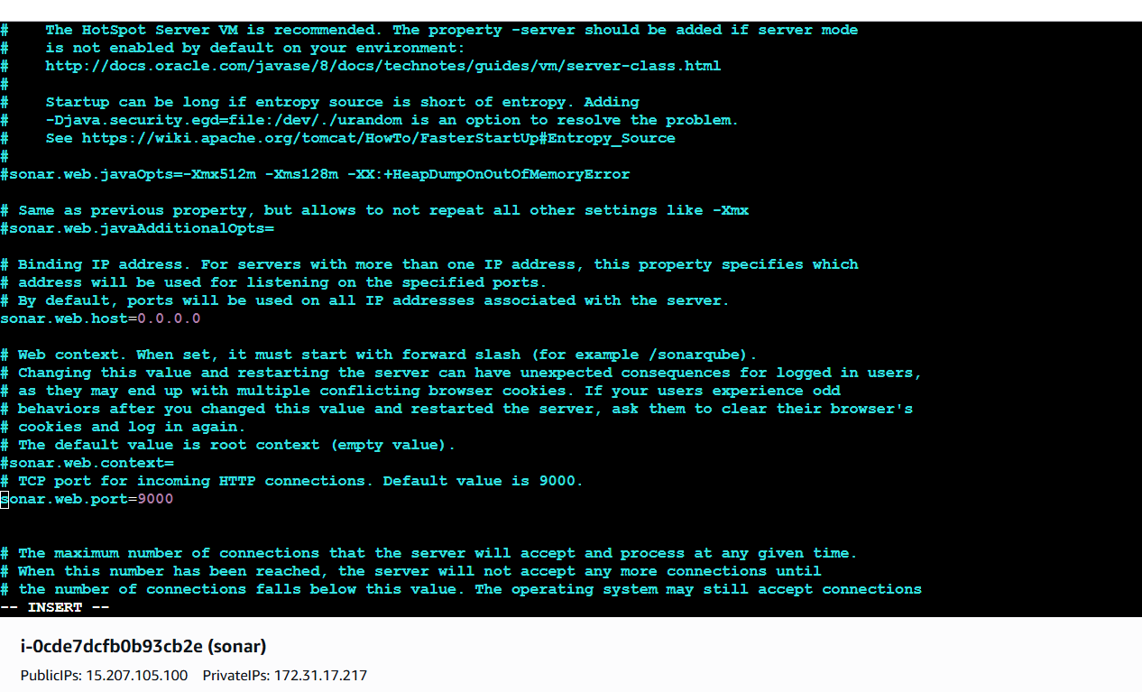
- Also remove “?currentSchema=my_schema”
- atsonar.jdbc.url=jdbc:postgresql://localhost/sonarqube?currentSchema=my_schema
- Save and exit

- sudo useradd sonar
- sudo passwd sonar
- sudo chown -R sonar:sonar /opt/sonarqube
- sudo vi /etc/sudoers.d/sonar
>>> sonar ALL=(ALL) NOPASSWD:ALL
sudo chmod 440 /etc/sudoers.d/sonar
- Adding user sonar to sudoers file ,,
- Switch to user “sonar” and start sonarqube

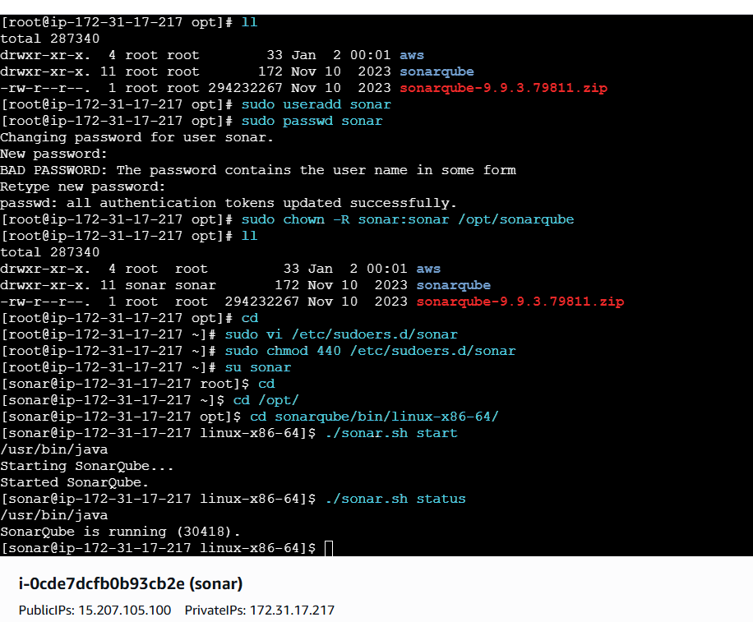
- Succesfully sonarqube is running.

- Ip of sonarqube-server:9000
- Default username and password for sonarqube is “admin”

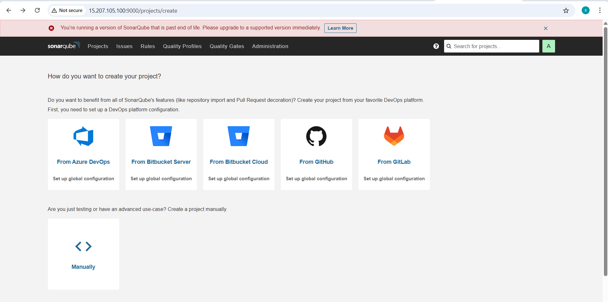
- My account > security > global token

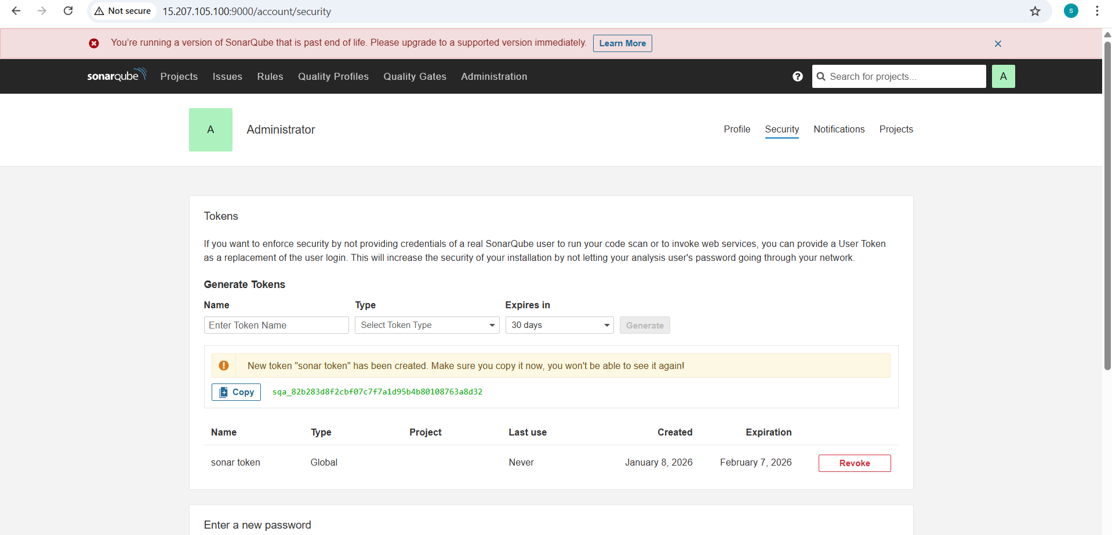
- Manage jenkins > credentials > global > add credential
- Select kind as “secret text “ paste the token created in secret

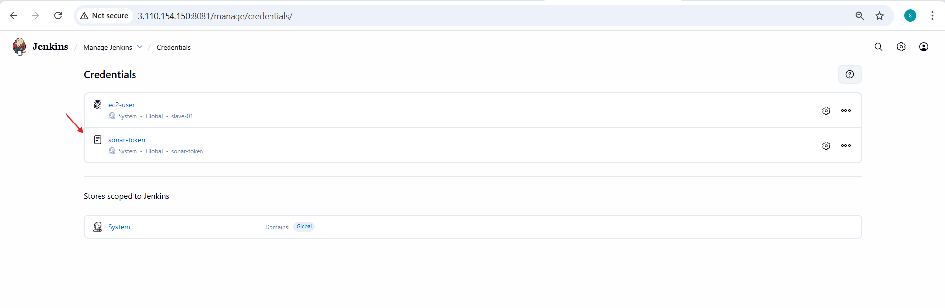
- Manage jenkins > system > add sonarqube
- Add name and server url , server authentication token from cre

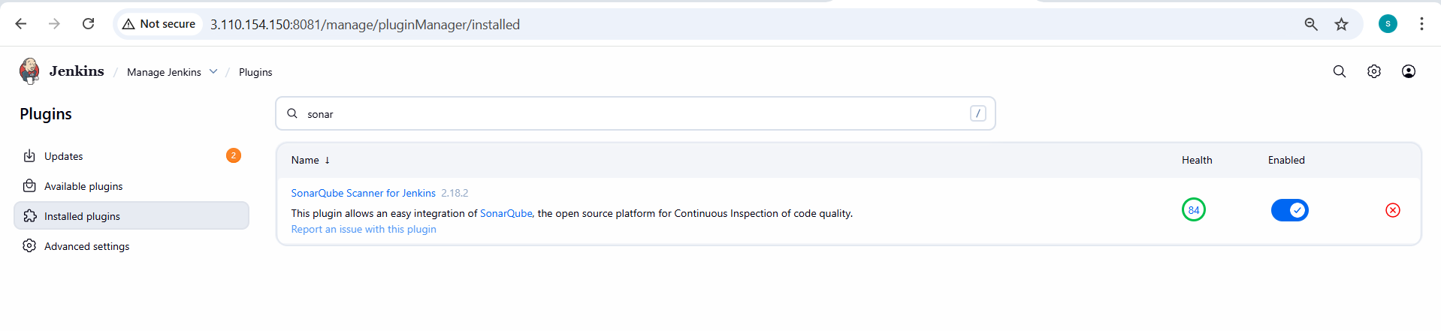

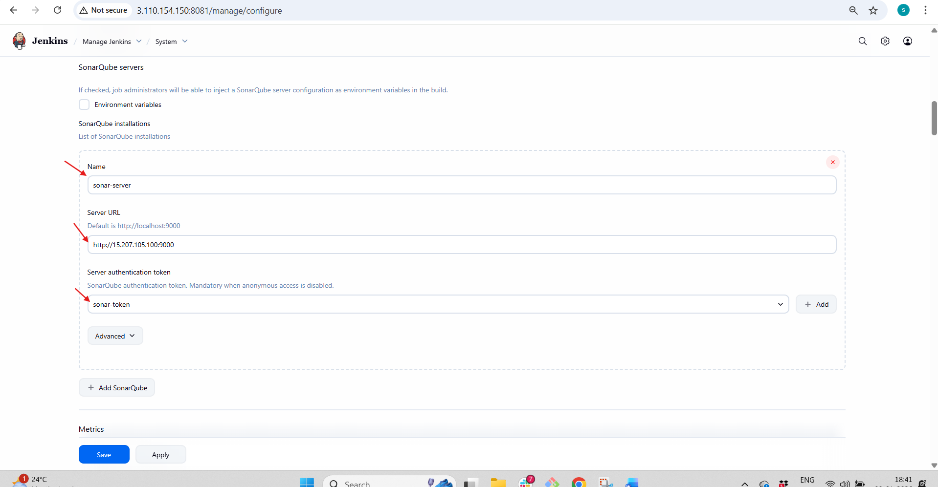
install sonar scanner on jenkins server :
- cd /opt
- sudo yum install -y unzip
- sudo wget https://binaries.sonarsource.com/Distribution/sonar-scanner-cli/sonar-scanner-cli-5.0.1.3006-linux.zip
- sudo unzip sonar-scanner-cli-5.0.1.3006-linux.zip
- sudo mv sonar-scanner-5.0.1.3006-linux sonar-scanner

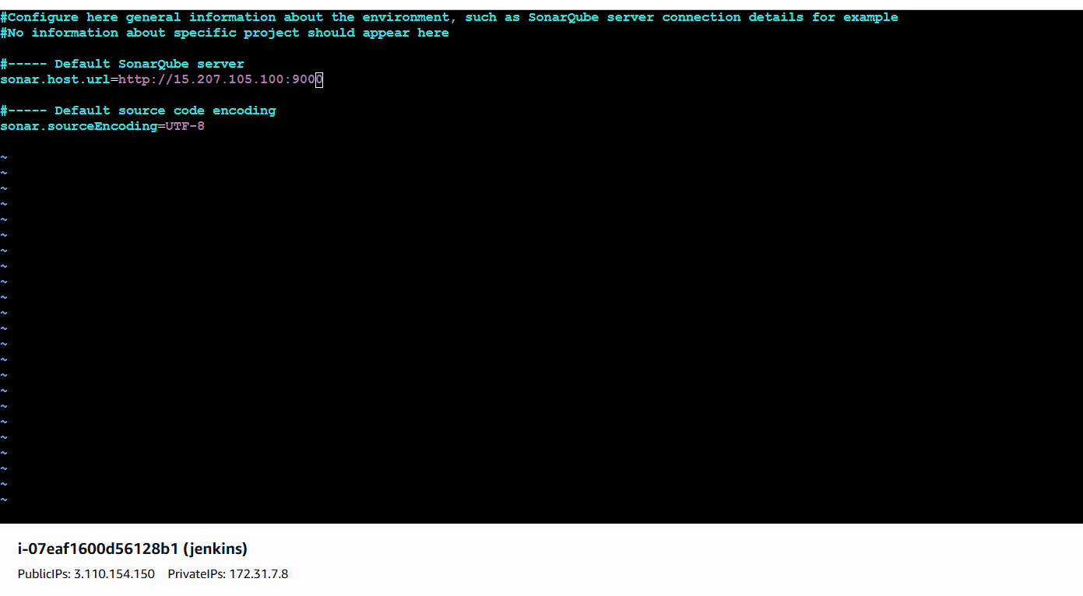
- In Jenkins gui :
- Manage jenkins > tools > sonar-scanner
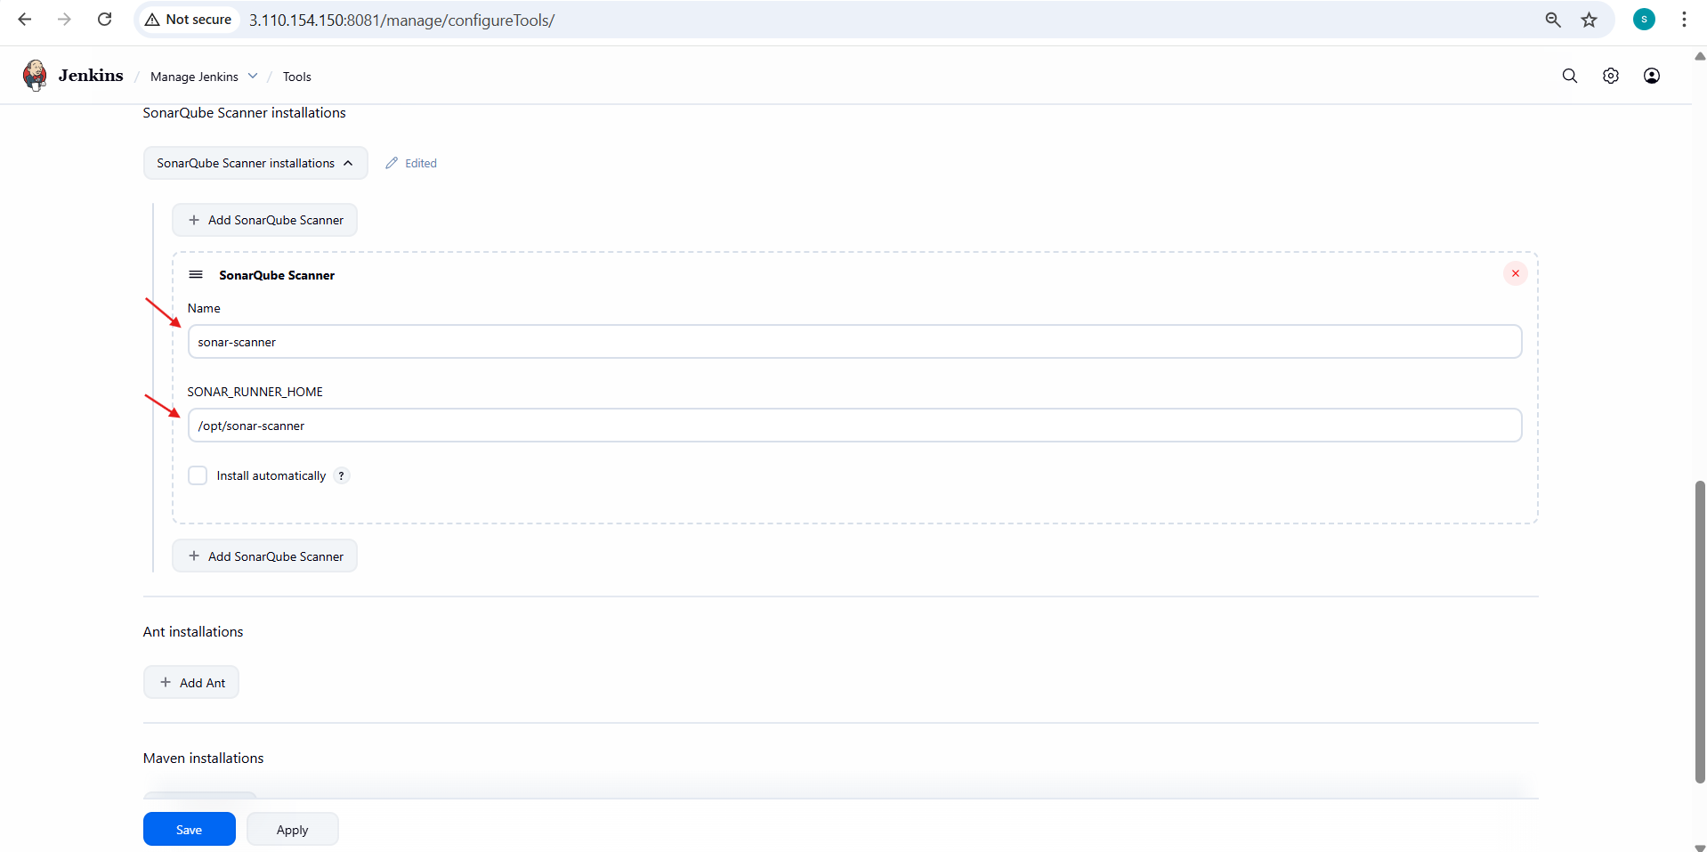
- Save and exit.
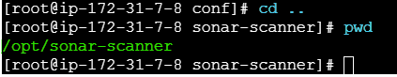

- Select the job created > configure > build steps > execute sonarqube-scanner

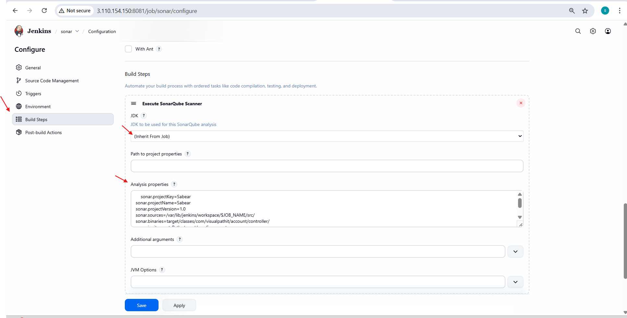

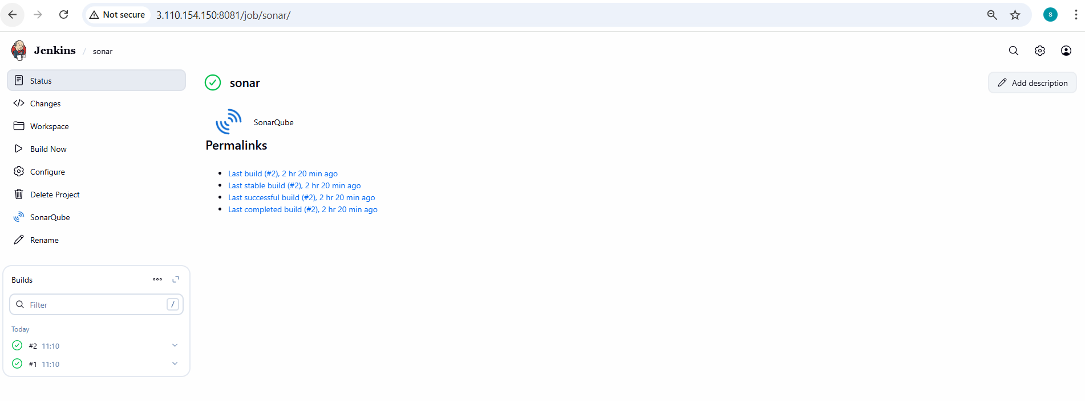

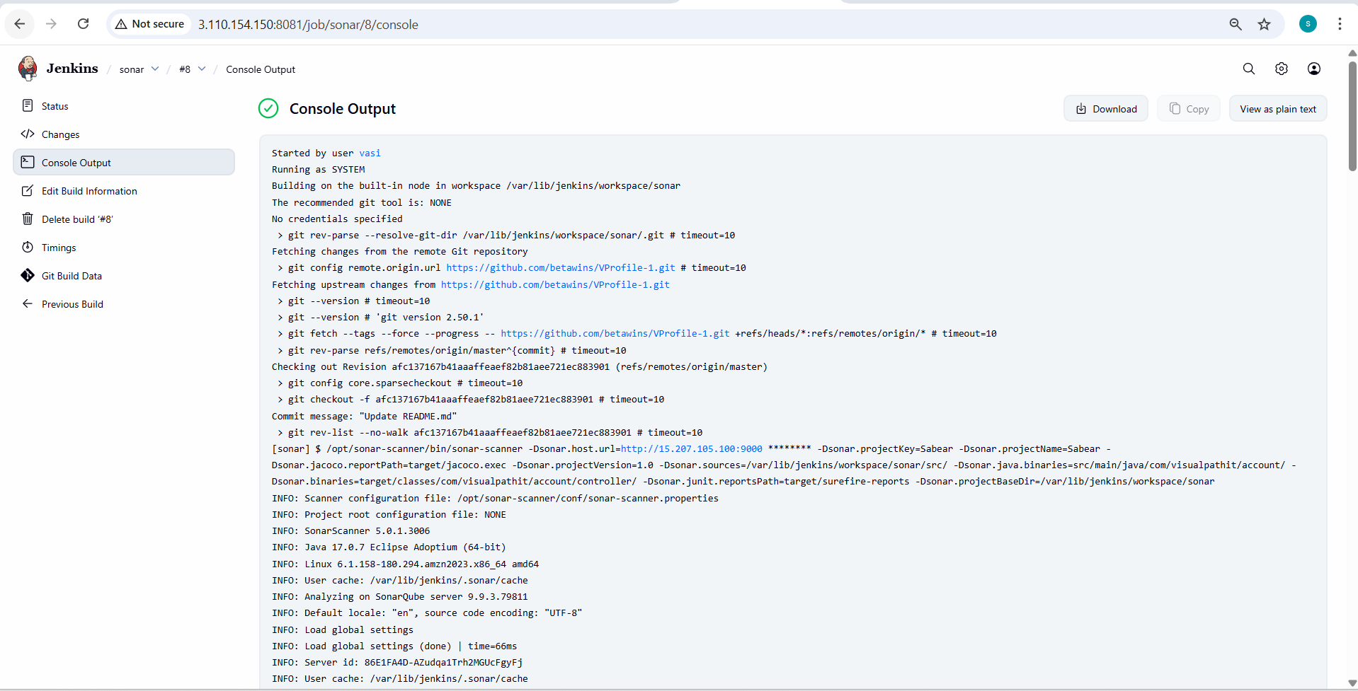

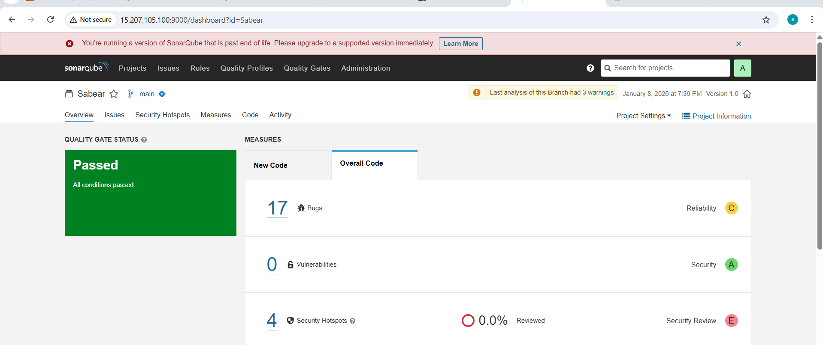

stage3: Slack Integration to send the alerts to slack.
- In jenkins install plugin “global slack notifier”
- Go to slack in browser >> more>> tools>> apps >> jenkins ci >> configure >> add to post channel

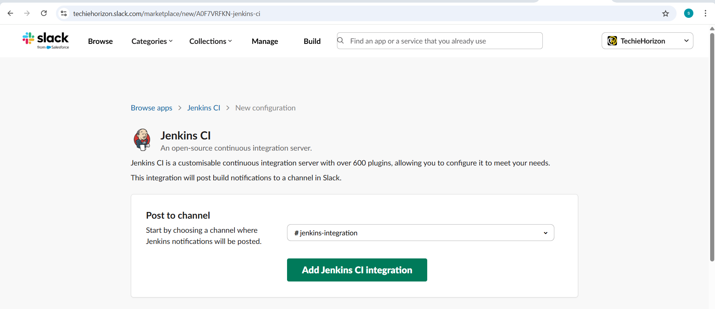

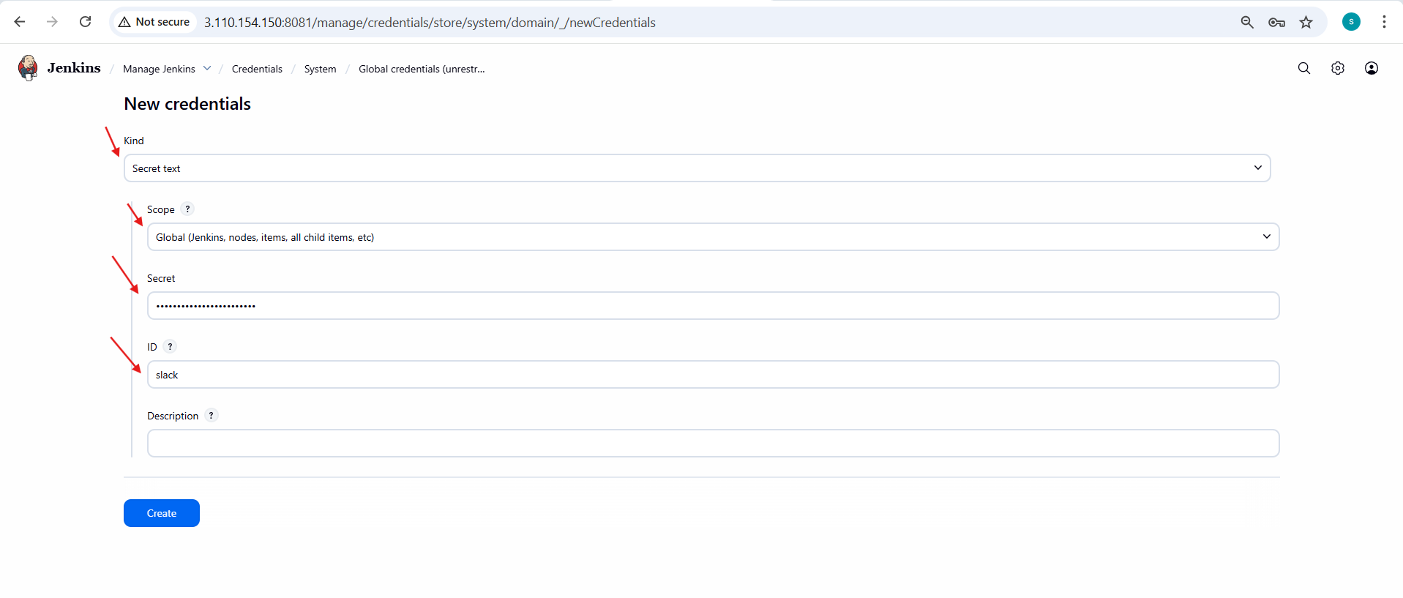
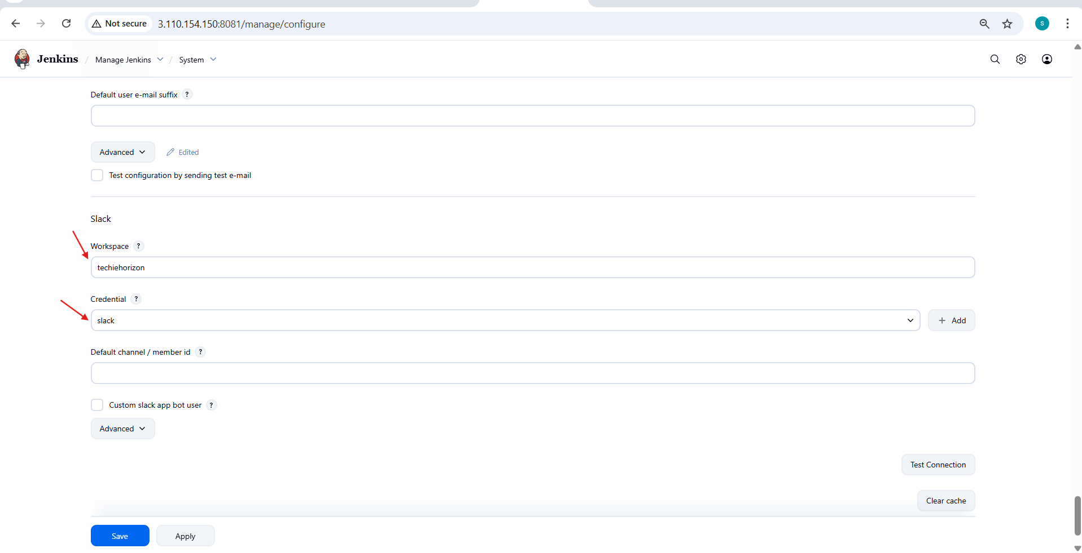
- In job configure >> post build actions >> slack notification

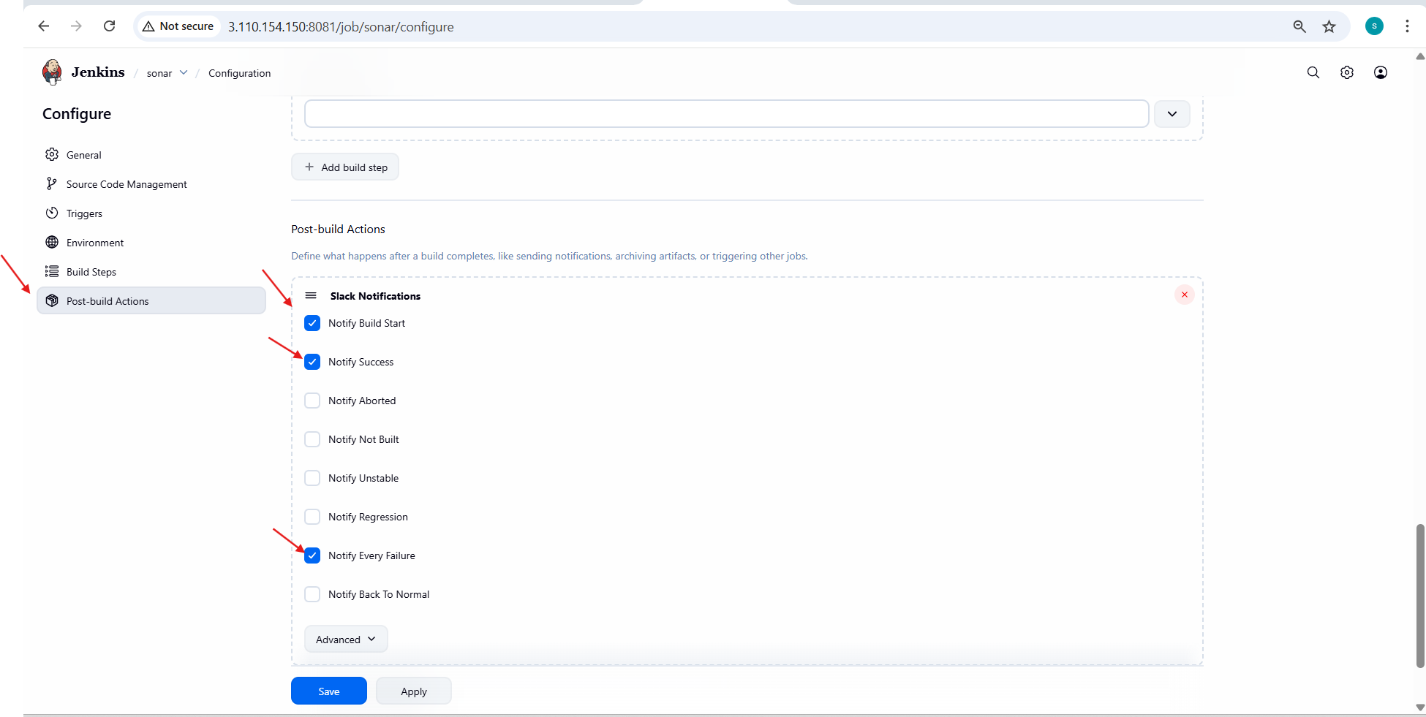

- Succesfully slack notifications jenkins integration done.

- Create one jenkins job using the below code and create three stages.

stage1: Git clone to download the source code.
stage2: Sonarqube Integration to check the quality of code
stage3: Slack Integration to send the alerts to slack.
URL: https://github.com/betawins/hiring-app.git
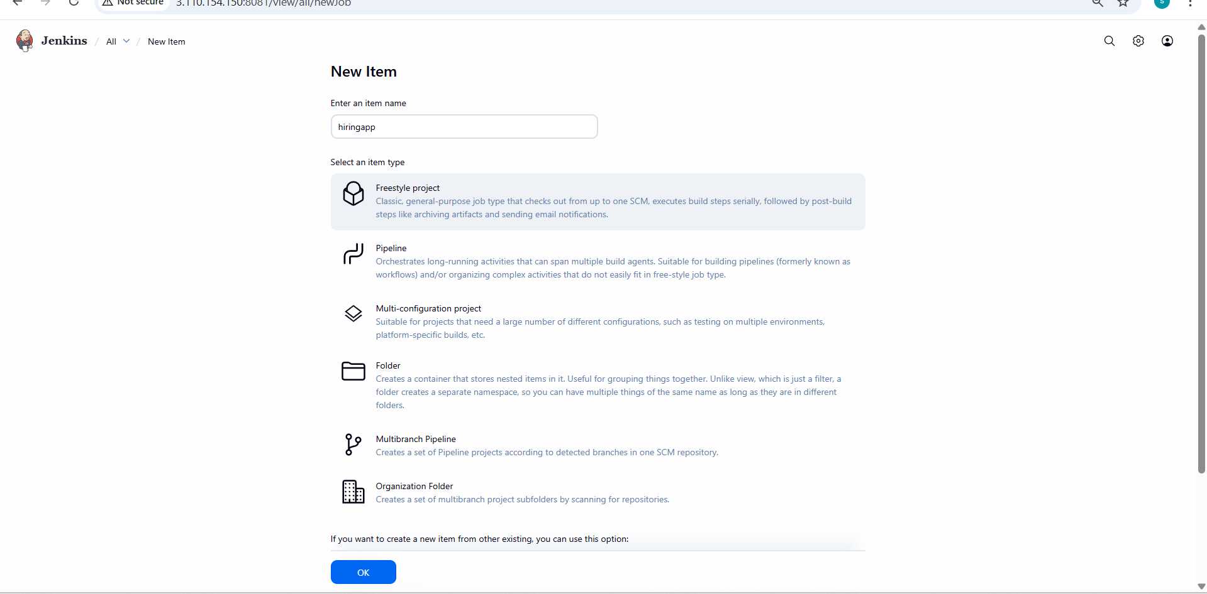
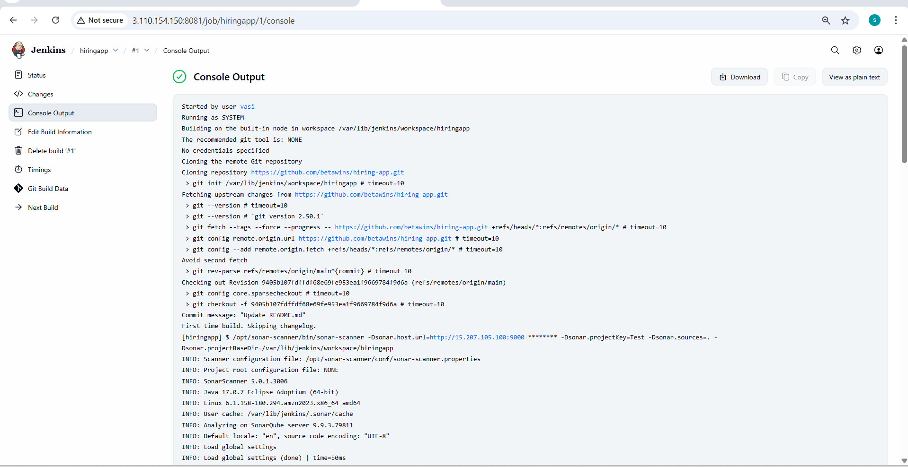
- code quality check
- 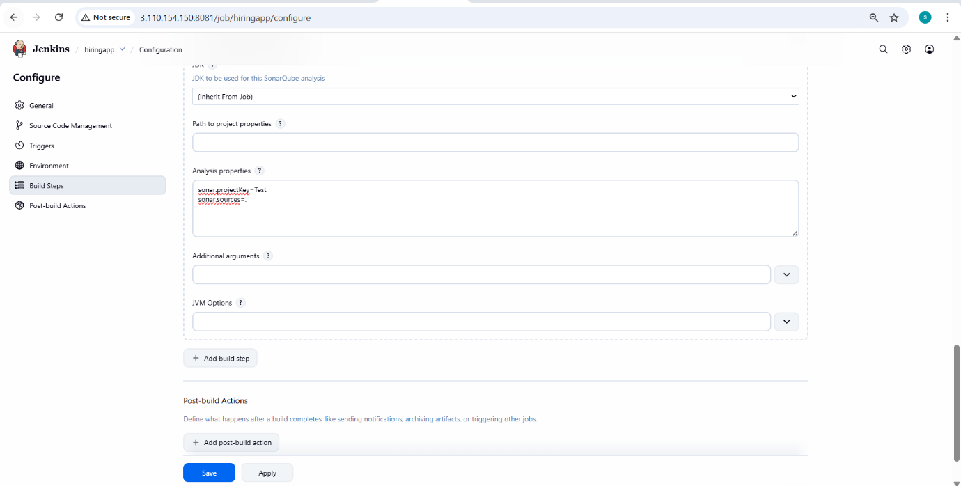
- slack alert notification.

